To begin our programme, we must add the .data to reserve a place in the memory for our variables (A,b, x, z, y, newLine) as shown in figure 1.1
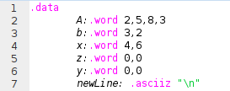

Figure 1.1

After reserving places in the memory for our variables, the assembler looks for the .text section where the code starts to compile. The first function that starts running is the main function where the addresses of the the variables that have been initialized are loaded in the save registers also known as $s registers as shown in figure1.2

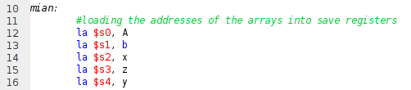
Figure 1.2

Afterwards, the lin_alg function will be called in order to add the two vectors b and x. In order to call lin_alg, the parameters needs to be prepared with their values where the parameters are added to the store argument registers or the $a registers for short as shown in figure 1.3
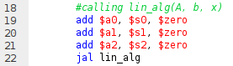

Figure 1.3

Before starting to run the code in the lin_alg function, we need to protect the values in the $a registers by pushing them to the stack. This is done by allocating spaces in the stack by moving the stack pointer ($sp for short) upwards relative to the memory address after that the values can be pushed where each value takes up a word (4 bytes of data) this process is shown in figure 1.4

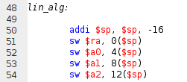

Figure 1.4

The first task the lin_alg function handles is calling another function which is add_vec
and since the function calls another function within it, it is categorized as a non-leaf function. Before jumping to the add_vec function, the $a registers need to be set up with their new values which are the b and x then the function can be called as shown in figure 1.5

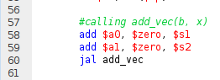

Figure 1.5

After branching to add_vec, the value of the return address in saved in the stack using the same way we initially saved the values at the start of the lin_alg function (refer to figure 1.4 for reference). First of all, the values of the $a registers start to copied to temporary registers ($t registers) so the original values of the $a registers are unchanged and available for use if needed later. $t0 and $t1 hold the address of the arrays b and x respectively, $t2 is as a counter and initialized with 0 and $t5 is the address of the array in $s3 which hold the variable z ( result of b + x). After everything is set up, we initialized a while loop by adding a while: label and an endWhile: label where the body of the loop will be encapsulated between both labels, the loop is used to loop on all the elements in the vectors and add them together, it is also done to avoid repetitive pieces of code. The first instruction in the body of the loop is a branch if equal where if the condition is met the a jump instruction is invoked, in this instruction, the value of $t2 is checked if its equal to 2 or not , if a that’s true it will branch to the endWhile: label else, it will continue executing instructions. If the condition is not met, the values of the first element in vector b and x start getting loaded in from the memory. The values that got loaded then get added to each other and saved in the $t3 register, then it gets saved in the first word(4 bytes) in the $t5 register. At this point this iteration of the loop is over and it is needed to jump back to the beginning of the loop, since this is not a high level programming language, we don’t get the luxuries of automatic increments like we get in a classic forloop, hence why after saving values in $t5, we manually increment $t0 and $t1 by 4 to fetch the next element in the vectors, then increment $t5 by 4 to save in the next empty element, and finally the $t2 (the counter) is incremented by 1 and finally the jump instruction jumps back to the start of the loop to start the process all over again this is shown in figure 1.6

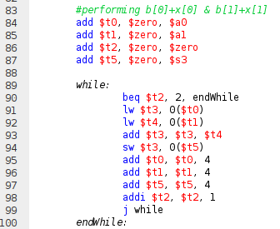

Figure 1.6
After adding the two vectors (b + x) and saving the result in $t5, the function needs to return the address in the $v0 register. Before moving $t5 to $v0, the $t5 hold the address of the results from ($s3) but the address is incremented by 8 since we incremented its value in the previous while loop and since the loop iterated twice, that means the $t5 has the address of the answer + 8 that’s why we must subtract 8 from the $t5 register. And then we can safely add $t5 to the $v0 register. That concludes the add_vec function, but before we exit, the $ra (return address) is saved away in the stack, hence why we need to pop the value of the $ra address before jumping back. (Figure 1.7)

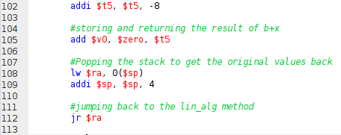

Figure 1.7

Figure 1.8 shows how after the jump to the return address instruction we start setting up the $a registers again before the next function call and in this case the function is mul_matrix. The $a0 is loaded with matrix A that is saved in the $s0 and $a1 is loaded with vector z which is the product of b+x which is saved in $v0

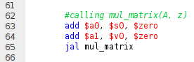

Figure 1.8

In the mul_matrix function, we start by adding the $ra to the stack to protect its value throughout the execution of the function. After adding the $ra to the stack, we need to setup our $t register before getting executing. For starters, $t0 will hold matrix A, $t1 will hold vector z, $t2 will act as a counter, $t8 will hold our first multiplication result (Row 1) and finally $t9 will hold the second multiplication result (Row 2). Refer to figure 1.9

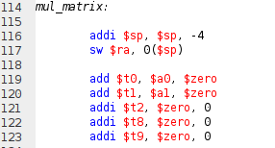

Figure 1.9

Now that the setup process is done, we’ll have a similar while loop to the one in the add_vec function but it has to have a different label since if the label stays “while” it will cause a compile error because of duplicate labels. So in order to avoid this issue, a the label will be called while2 and the endWhile2 for the same reasons. After initializing the loop, we need to split the multiplication process this is done because the multiplication of matrices requires the matrix to be split in two, where the first half is multiplied by the vector once, and is the first element in the result vector, then the second half is multiplied by the same vector and result acts as the second element in the result vector. Matrix multiplication is shown in figure 2.11

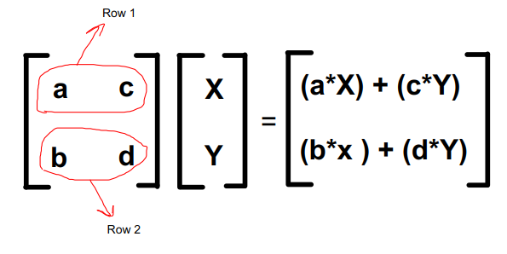

Figure 2.11

Now that the steps that are needed to be done are clear, all we need to do is take the first row (Row 1) and multiply it by the vector. First we need to add the label row1 and row2 and preRow2, details about the labels will come later. Then the first instruction in row1 is a condition that compares $t2(the counter) to 2 this means that we have iterated through row1 twice that means that the next array element to be fetched from the $t0 is from row2 hence why if the condition is met, a branch to preRow2 will be invoked. Else, an element of the array in $t0 will be loaded in from the memory to $t3 and a an element from the $t1 will be loaded to $t4. Now that we have fetched the equivalent of a and X (figure 2.11) we need to multiply them and save them in a register, in our case, $t3 is used to save the result of the multiplication. And to finalize the first iteration of our loop, we add the result in $t8 which is where the summation of the first row multiplications is saved. At this point, the first iteration of the loop is complete and as mentioned before, after the values are all calculated, $t0 and $t1 need to be incremented by 4 in order to fetch the next elements in both arrays and the counter needs to be incremented by 1. Finally a jump instruction is invoked in order to jump back to row1. After iterating twice in the while loop, and finishing the first row multiplication, the condition in the first line in row1 will cause a branch to preRow2, there the only instruction that is executed is to reset the address of the $t1 (hold the $a1) to its original address, this wasn’t done since the next value of the $t0 (holds $a0) is the value that we expect which is the first element in row 2 but since this element will be multiplied by the same vector, a reset to the address that’s saved in $t1 is needed and start from word offset zero. Refer to figure 2.12 for more details.

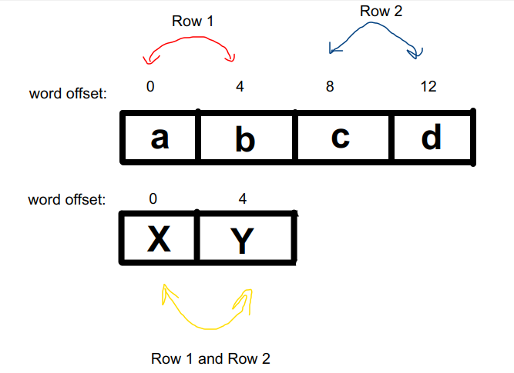

Figure 2.12

Afterwards, the programme starts executing code from the row2 label and its a very similar process that we did in row 1 but instead of saving the result in $t8, it is saved in $t9. When two iterations of the loop are over, a jump command is invoked to end the loop and start the post loop process. Refer to figure 2.13

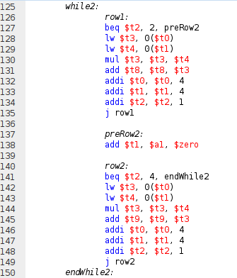

Figure 2.13

After the values have been calculated, we save them in the $s4 register which is the register that hold the address of the y array where the result should be stored. (refer to figures 1.1 and 1.2) after the results have been stored, it is necessary to move the value from $s4 to $v0 which is where the return of this function will be stored. That concludes the mul_matrix function. But before returning to the main function, we need to pop the $ra from the stack then we can jump back to the
lin_alg function. Refer to figure 2.2
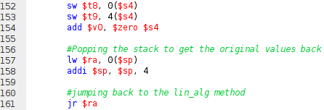

Figure 2.2

After returning to the lin_alg function, we start popping the original values of the $a registers from the stack then jumping back to the main function with the $v0 already setup with the address of the result vector and saved in $s4. Refer to figure 2.3

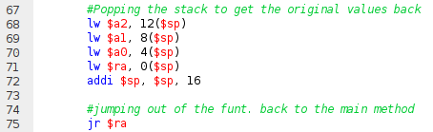

Figure 2.3

Now, the last step is to print the values calculated, First we load the first number that needs to be printed in the $t1 register. Then, load the $v0 with a value of 1 and the pass the number that needs to be printed as a parameter using the $a0. Finally, a syscall is invoked, and since the $v0 is set to 1, we will use the print integer syscall. After every number printed, we need to add a new line, therefore, we passed the address where the ascii code of the new line character is stored and set the $v0 to 4 which indicated “print string” and then we do the same process of printing an integer to using print integer syscall. When the process is complete, the programme jumps to the exit label. Refer to figure 2.4

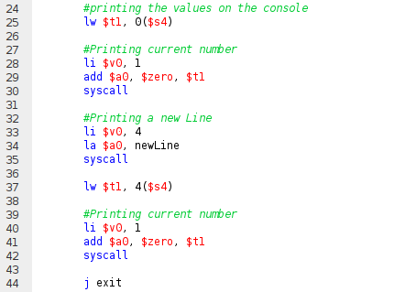

Figure 2.4

